**Question 1**

Fill in the truth table for the Logic Gate shown.

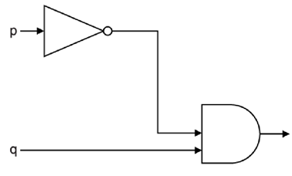

|  |  |  |
| --- | --- | --- |
| **p** | **q** | **Output** |
| 0 | 0 |  |
| 0 | 1 |  |
| 1 | 0 |  |
| 1 | 1 |  |

**Question 2**

Fill in the truth table for the Logic Gate shown.

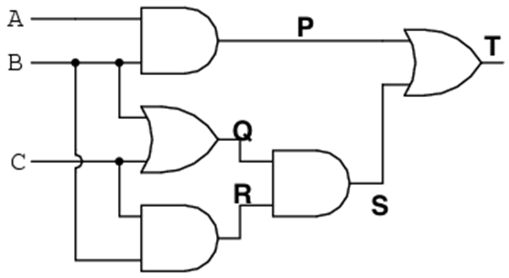

|  |  |  |  |  |  |  |  |
| --- | --- | --- | --- | --- | --- | --- | --- |
| **A** | **B** | **C** | **P** | **Q** | **R** | **S** | **T** |
| 0 | 0 | 0 |  |  |  |  |  |
| 0 | 0 | 1 |  |  |  |  |  |
| 0 | 1 | 0 |  |  |  |  |  |
| 0 | 1 | 1 |  |  |  |  |  |
| 1 | 0 | 0 |  |  |  |  |  |
| 1 | 0 | 1 |  |  |  |  |  |
| 1 | 1 | 0 |  |  |  |  |  |
| 1 | 1 | 1 |  |  |  |  |  |

**Question 3**

Fill in the **X column** for the Logic Gate shown. (There are spare columns if you want to use them). Note there is a new symbol in use…. Check out [this link](https://www.electronics-tutorials.ws/boolean/bool_7.html) to figure out it’s truth table

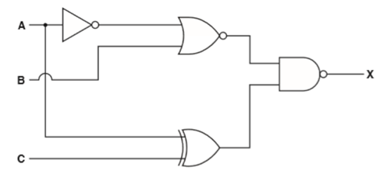

|  |  |  |  |  |  |  |
| --- | --- | --- | --- | --- | --- | --- |
| **A** | **B** | **C** |  |  |  | **X** |
| 0 | 0 | 0 |  |  |  |  |
| 0 | 0 | 1 |  |  |  |  |
| 0 | 1 | 0 |  |  |  |  |
| 0 | 1 | 1 |  |  |  |  |
| 1 | 0 | 0 |  |  |  |  |
| 1 | 0 | 1 |  |  |  |  |
| 1 | 1 | 0 |  |  |  |  |
| 1 | 1 | 1 |  |  |  |  |